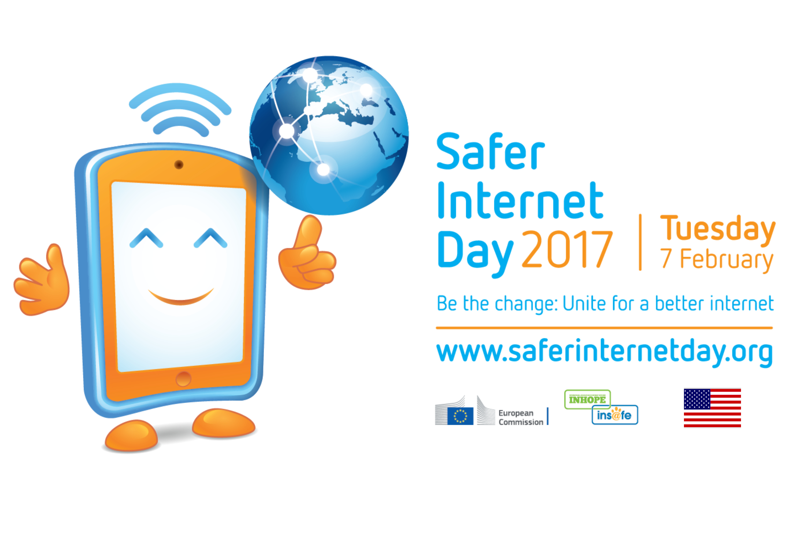

US Partner Tool Kit
SaferInternetDay.us

Hosted in the US by
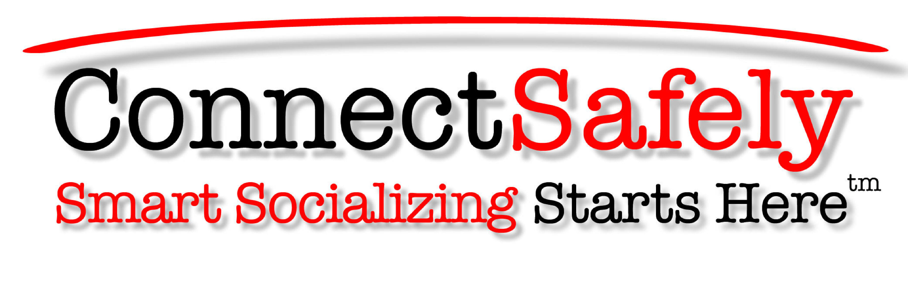

FOR MORE INFORMATION:
SID@ConnectSafely.org
Thank you for joining internet users and organizations across the United States and around the world in celebrating Safer Internet Day on February 7! It's the one day of the year when people all over the planet are sending the message that making the internet great for everybody takes everybody.

What You Can Do
Key Messages
Sample Social Media Text & Images
Partners http://bit.ly/SIDUSpartners
Supporters http://bit.ly/SIDUSsupporters

What You Can Do

As the host of Safer Internet Day (SID) in the United States, ConnectSafely invites you to celebrate Safer Internet Day on Feb. 7 in the following ways:

In the Classroom

- Use one of our Safer Internet Day lesson plans http://saferinternetday.us/lesson-plans/
- Participate in our Safer Internet Day livestream event from the National Constitution Center in Philadelphia. Contact SID@connectsafely.org to sign up. View the livestream on Feb. 7 at www.SaferInternetDay.us.

At Home or Work

- Let’s spread an epidemic of kindness! Think of a good thing you’ve done or seen somebody else do to make the internet a better place or the world a better place with the help of the internet (see examples at OneGoodThing.org), then share it with a little text or video at http://saferinternetday.us/one-good-thing/. We’ll pick the best ones to share on Safer Internet Day.

Key Messages

- Safer Internet Day increases public awareness that a safe and civil internet depends on all of us
- Youth participation in Safer Internet Day is imperative because young people are key stakeholders in any discussion about online safety. All stakeholders need a “place at the table” in making the internet work for all.

Sample Social Media Text & Images

Hashtags: #SID2017 and #SaferInternetDay

Twitter: @ConnectSafely
Facebook: www.facebook.com/ConnectSafely

Sample Social Posts

- #SaferInternetDay is all about creating a better, safer internet for us and our kids. Let’s work together - check out the US campaign for 2017 at http://bit.ly/SIDUS. #SID2017 @ConnectSafely
- Proud supporter of #SaferInternetDay, hosted in the US by @ConnectSafely. Learn more at http://bit.ly/SIDUS #SID2017
- It’s YOUR Internet. Let’s create a better one together. #SaferInternetDay #SID2017 http://bit.ly/SIDUS
- I shared my #OneGoodThing for #SaferInternetDay. Add yours #SID2017 http://bit.ly/SIDUS
- [ORGANIZATION] joins @ConnectSafely in support of #SaferInternetDay. Learn how to get involved http://bit.ly/SIDUS #SID2017
- Use @ConnectSafely resources to promote #SaferInternetDay in your classroom or office: http://bit.ly/SIDUS #SID2017
- Celebrate #SaferInternetDay Feb. 7 – join the livestream and add your voice to the discussion http://bit.ly/SIDUS #SID2017
Week of February 5:

- #SaferInternetDay is Feb 7! Check out the US livestream at http://bit.ly/SIDUS #SID2017
- Feb 7 is #SaferInternetDay. Celebrate with US and @ConnectSafely at http://bit.ly/SIDUS #SID2017
- Have a Happy #SaferInternetDay – let’s unite for a better internet! #SID2017 http://bit.ly/SIDUS

Facebook Image

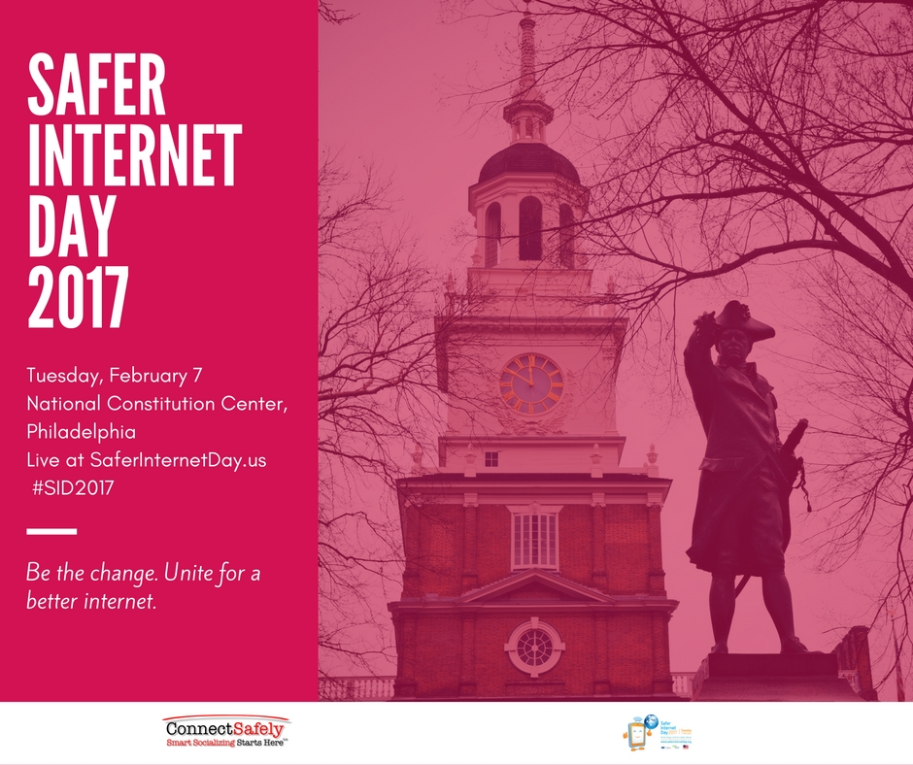

Twitter Image

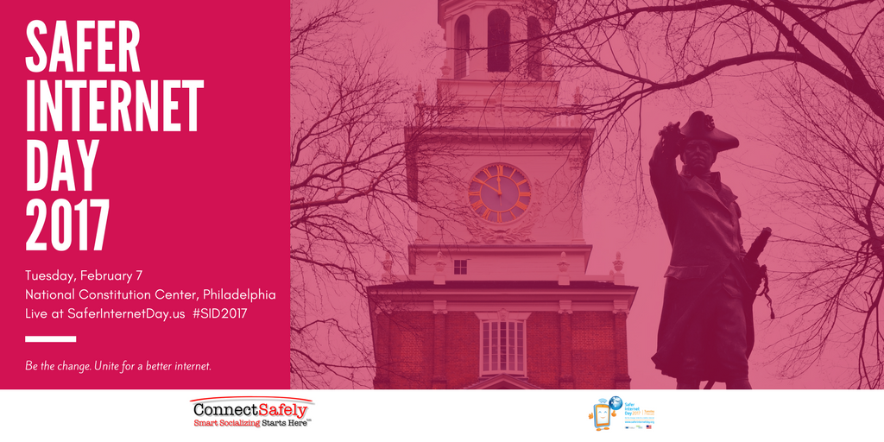

Logo

Safer Internet Day US Steering Committee

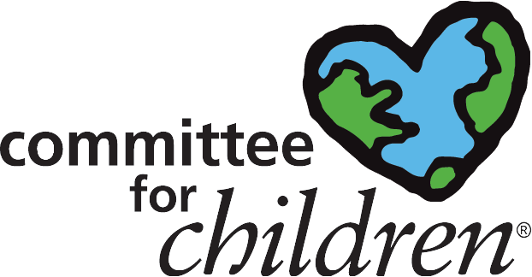
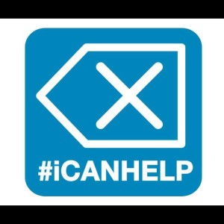

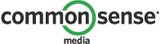

Safer Internet Day US Supporters

