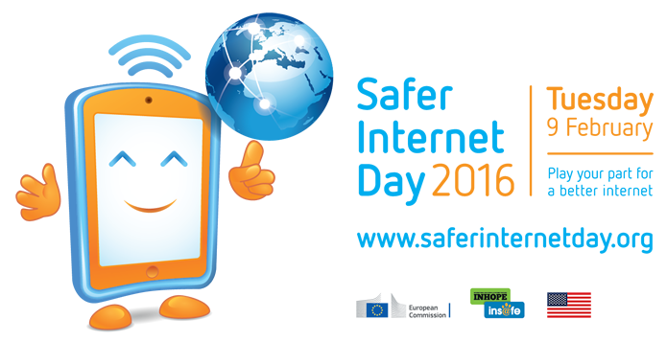

US Partner Tool Kit
SaferInternetDay.us

Hosted in the US by

FOR MORE INFORMATION:
SID@ConnectSafely.org
Thank you for joining Internet users and organizations across the United States and around the world in celebrating Safer Internet Day on February 9! It's the one day of the year when people all over the planet are sending the message that making the Internet great for everybody takes everybody.

What You Can Do
Key Messages
Sample Social Media Text & Images
Partners http://bit.ly/SIDUSpartners
Supporters http://bit.ly/SIDUSsupporters
2015 Year in Review http://bit.ly/SID2015rewind

What You Can Do

As the host of Safer Internet Day (SID) in the United States, ConnectSafely invites you to celebrate Safer Internet Day on Feb. 9 in the following ways:

In the Classroom

- Use one of our Safer Internet Day lesson plans http://saferinternetday.us/lesson-plans/
- Participate in our Safer Internet Day livestream event from Universal Studios Hollywood. Contact SID@connectsafely.org for educator materials and to sign up. View the livestream on Feb. 9 at www.SaferInternetDay.us.

At Home

- Read, discuss and sign the family pledge for smart use of technology http://saferinternetday.us/family%20pledge/

Key Messages

- Safer Internet Day increases public awareness that a safe and civil Internet depends on all of us
- Youth participation in Safer Internet Day is imperative because young people are key stakeholders in any discussion about online safety. All stakeholders need a “place at the table” in making the Internet work for all.

Sample Social Media Text & Images

Hashtags
US: #SIDUS16
Global: #SID2016

Twitter: @ConnectSafely
Facebook: www.Facebook.com/ConnectSafely

Sample Facebook Posts

Week of December 14:

- #SaferInternetDay is all about creating a better, safer Internet for us and our kids. Safer Internet Day, celebrated on Feb 9, 2016, emphasizes working together to improve the Web. Check out the campaign and start planning for 2016 at http://bit.ly/SIDUS. #SIDUS16
- Spread the word! Promote safe online habits for Safer Internet Day and all year by taking a family pledge for smart use of technology. Learn more at http://bit.ly/SIDFamilyPledge #SIDUS16
- Proud supporter of #SaferInternetDay, hosted in the US by @ConnectSafely. Learn more at http://bit.ly/SIDUS #SIDUS16

Week of January 4:

- [ORGANIZATION] joins @ConnectSafely in support of Safer Internet Day. Learn how to get involved at http://bit.ly/SIDUS #SIDUS16
- Everyone has a role to play in keeping ourselves – and each other – safe online. Join @ConnectSafely for Safer Internet Day and take the family pledge for smart use of technology http://bit.ly/SIDFamilyPledge #SIDUS16

Week of January 11:

- Join #SaferInternetDay by taking steps to stay safe online. Start by setting strong passwords with 8+ characters and a combination of upper and lowercase letters along with special characters. Learn more at ConnectSafely.org #SIDUS16
- [COMPANY NAME] is a proud supporter of #SaferInternetDay, hosted in the US by @ConnectSafely. Join us http://bit.ly/SIDUS #SIDUS16

Week of January 18:

- Spread the word! Promote safe online habits all year by becoming a Friend of the #SaferInternetDay Campaign. Learn more at http://bit.ly/SIDUS #SIDUS16
- YES, I PLEDGE to join my family in staying safe online! http://bit.ly/SIDFamilyPledge #SIDUS16

Week of January 25:

- There r 2 weeks until #SaferInternetDay but it’s not too late to become a Friend of the Campaign! Encourage your workplace, school or clients to sign up – it’s easy and free to show your support! http://bit.ly/SIDUS #SIDUS16

Week of February 1:

- YES, I PLEDGE to join my family in staying safe online in honor of #SaferInternetDay Feb. 9! http://bit.ly/SIDFamilyPledge #SIDUS16
- Proud supporter of #SaferInternetDay, hosted in the US by @ConnectSafely. Join us http://bit.ly/SIDUS #SIDUS16

Sample Twitter Posts

Week of December 14:

- Celebrate #SaferInternetDay on Feb. 9 by signing up to be a partner. It’s easy & free! http://bit.ly/SIDpartner #SIDUS16
- #SaferInternetDay (Feb. 9) is about working together 2 create a better, safer Web. Start planning for 2016: http://bit.ly/SIDUS #SIDUS16
- Promote safe online habits all year by taking a family pledge for smart use of technology. Learn more at http://bit.ly/SIDFamilyPledge #SIDUS16
- It’s YOUR Internet. Let’s create a better one together #SIDUS16 #SaferInternetDay http://bit.ly/SIDUS

Week of January 4:

- During #SaferInternetDay, stay aware and safe online with strong & secure passwords. Find more tips http://bit.ly/SIDUS #SIDUS16
- Become a partner of #SaferInternetDay and play your part for a better Internet http://bit.ly/SIDpartner #SIDUS16
- [ORGANIZATION] recognizes 3 years of promoting Internet safety with the US #SaferInternetDay Campaign #SIDUS16 @ConnectSafely
- Proud supporter of #SaferInternetDay, hosted in the US by @ConnectSafely. Join us http://bit.ly/SIDUS #SIDUS16
- Join us & @ConnectSafely in taking a pledge for smart use of tech by keeping ourselves & others safe online http://bit.ly/SIDFamilyPledge #SIDUS16
Week of January 11:

- Use @ConnectSafely resources to promote #SaferInternetDay in your classroom or office: http://bit.ly/SIDUS #SIDUS16

Week of January 18:

- Play your part for a better Internet, be a #SaferInternetDay Friend of the Campaign at http://bit.ly/SIDUS #SIDUS16
- Are you in the LA Area? Attend #SaferInternetDay at @UniStudios http://bit.ly/SIDUS #SIDUS16
- YES, I PLEDGE to join my family in staying safe online! http://bit.ly/SIDFamilyPledge #SIDUS16

Week of January 25:

- #SaferInternetDay is around the corner, have you talked to your kids about #OnlineSafety? Learn more http://bit.ly/SIDFamilyPledge #SIDUS16

Week of February 1:

- Celebrate #SaferInternetDay next week by joining the Feb. 9 livestream at http://bit.ly/SIDUS #SIDUS16
- Just a few days till Feb. 9 #SaferInternet Day, find out how to celebrate at http://bit.ly/SIDUS #SIDUS16

Week of February 8:

- #SaferInternetDay is tomorrow! Check out the livestream from @UniStudios at http://bit.ly/SIDUS #SIDUS16
- Don’t miss #SaferInternetDay livestream at http://bit.ly/SIDUS #SIDUS16
- Tweet your questions for #SaferInternetDay using #SIDUS16 live tomorrow http://bit.ly/SIDUS
- 3rd annual #SaferInternetDay in the US is tomorrow! Watch the event life from @UniStudios at SaferInternetDay.us http://bit.ly/SIDUS #SIDUS16

February 9 – Safer Internet Day:

- Join #SaferInternetDay Feb 9 livestream event SaferInternetDay.us #SIDUS16
- Feb 9 marks #SaferInternetDay. Celebrate with us and @ConnectSafely at http://bit.ly/SIDUS #SIDUS16
- Have a Happy #SaferInternetDay – let’s create a better Internet together! #SIDUS16 http://bit.ly/SIDUS
- Are you helping to make the Internet a better and safer place? Join us Feb 9 #SaferInternetDay worldwide http://bit.ly/SIDUS #SIDUS16

Logo

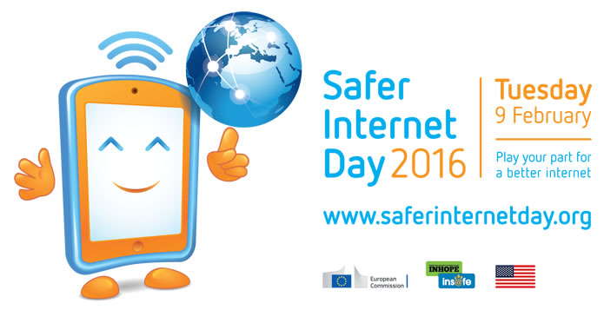

Safer Internet Day Steering Committee

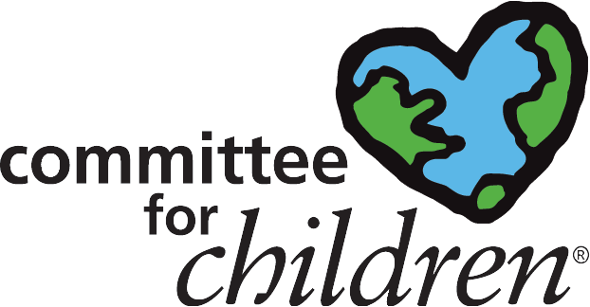
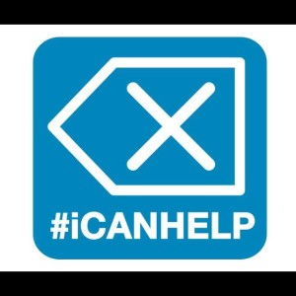

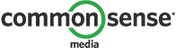

Safer Internet Day Supporters

